Prayer for the Earth—Pope Francis, Laudato Si

All-powerful God, you are present in the whole universe
and in the smallest of your creatures.
You embrace with your tenderness all that exists.
Pour out upon us the power of your love,
that we may protect life and beauty.
Fill us with peace, that we may live
as brothers and sisters, harming no one.
O God of the poor,
help us to rescue the abandoned and forgotten of this earth,
so precious in your eyes.
Bring healing to our lives,
that we may protect the world and not prey on it,
that we may sow beauty, not pollution and destruction.
Touch the hearts
of those who look only for gain

Prayer for the Earth—Pope Francis, Laudato Si

All-powerful God, you are present in the whole universe
and in the smallest of your creatures.
You embrace with your tenderness all that exists.
Pour out upon us the power of your love,
that we may protect life and beauty.
Fill us with peace, that we may live
as brothers and sisters, harming no one.
O God of the poor,
help us to rescue the abandoned and forgotten of this earth,
so precious in your eyes.
Bring healing to our lives,
that we may protect the world and not prey on it,
that we may sow beauty, not pollution and destruction.
Touch the hearts
of those who look only for gain

at the expense of the poor and the earth.
Teach us to discover the worth of each thing,
to be filled with awe and contemplation,
to recognize that we are profoundly united
with every creature
as we journey towards your infinite light.
We thank you for being with us each day.
Encourage us, we pray, in our struggle
for justice, love and peace.

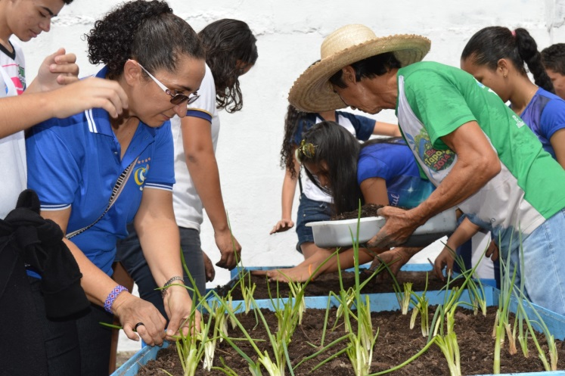

at the expense of the poor and the earth.
Teach us to discover the worth of each thing,
to be filled with awe and contemplation,
to recognize that we are profoundly united
with every creature
as we journey towards your infinite light.
We thank you for being with us each day.
Encourage us, we pray, in our struggle
for justice, love and peace.

